Keep the Doors Open
January 9, 2020
Friends of Dorr Township Library Informational Meeting

Intro:

Friends of Dorr Township Library (FODTL)

Who we are- Friends of Dorr Township Library is a 501(c)3 nonprofit organization. Currently we are directed by 6 founding board members. Board members have a 3 year terms, and in the future will be elected by members of Friends of Dorr Township Library.

When we started- September 2019, nonprofit since December 2019.

What we do- Our mission is to support the library by assisting them where other funding is not available. This can be anything from volunteering in the library, helping with fundraisers, advocacy for the library, and community outreach.

DTL Brief Financial/Millage History:

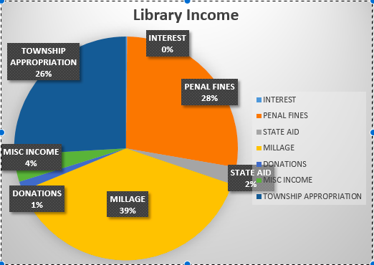
DTL gets its funding from different the different sources shown here: (graphic 1)
Millage History:

2010 - .3 mil for 10 years was voted for by Dorr Township residents. Prior to this millage, the township had an appropriation for the library of $94,850.

Spring 2019 - .8 mil was requested from the library. With .3 mil being a renewal and .5 mil an increase. Purpose: to keep up with rising costs and be able to maintain adequate funding for the next 10 years. Failed 1,070 to 634.

August 2019- 1 mil was requested from the library. Still .3 as a renewal, and now a .7 mil increase. Purpose: same as spring millage, plus ability to obtain some up and coming library resources and technology, and to be able to make some improvements to the building and library infrastructure. Failed 629 to 529.

Current Focus:

Millage – Currently DTL is seeking .6 mil. DTL is one of the lowest funded libraries of its size in the area. (graphic 2)
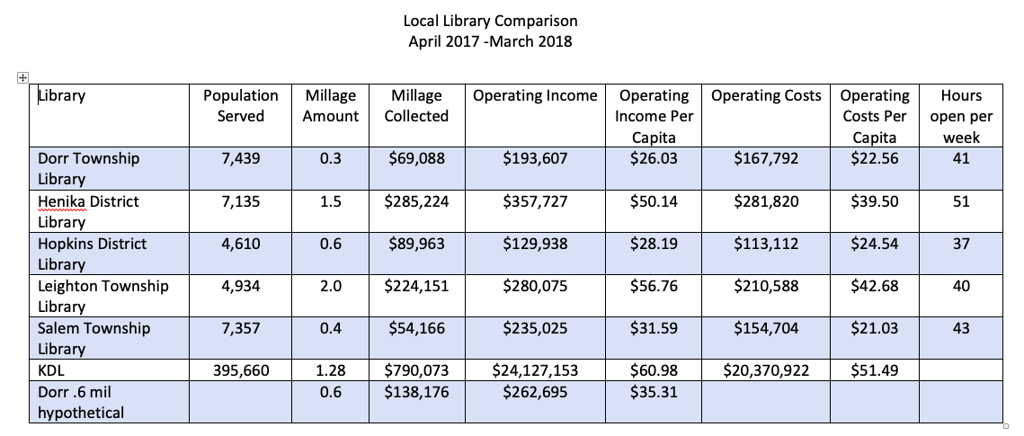

The purpose statement for this millage is as follows:

Millage Purpose Statement

The Dorr Township Library Board is requesting a 10 year .6 mil on the March 10, 2020 ballot. The millage request is a renewal of the .2951 mil currently received, along with an increase of .3049 mil. The Dorr Township Library Board felt the need to vote for a request of additional funds believing the library is at capacity with funding for collections, staff, programs, facilities and services. Dorr Township Library is one of the lowest funded libraries of its size in the area, the new millage would ensure that Dorr Township Library will continue to be a viable cornerstone in our community. The increase will enable our Library to meet the changing needs of our community in a world of increasing technology. It would provide a shorter wait time for books of all formats for our patrons and be a source for relevant and useful programing and services. The Library Board looks forward to inviting the community to help with strategic planning for the future of Dorr Township Library. Without a passing millage in 2020, the Dorr Township Library will be forced to close its doors in early 2021.

Target Audience – Voters who did not feel informed enough to vote yes last time around, and voters who did not feel motivated enough to vote at all.

FODTL Game Plan:
- Ask community businesses for funding, donated to either the library or the friends group to offset the cost of mailings and the ballot cost for running in March.
- Fundraiser at 5 Lakes Brewing – 10% of sale on a Sunday afternoon. (Date TBD/February)
- Book sale and bake sale to raise funds and promote awareness of the March 10th election. (February 26-29)
- Fact checking.
- Community outreach through Facebook, emails, and informational tables set up throughout the community, as well as canvasing neighborhoods on foot.

What can you do:
-Donate money https://friendsofdtl.square.site/
-Donate time (sign ups available on back table) and more to opportunities to come.
-Talk to your neighbors about the importance of our library
-Post and share about the library on Facebook. Make sure it’s factual. Avoid responding to negative feedback.
-Attend DTL board meetings (third Monday of the month at 7pm) to keep up to date, and have a voice in what happens next.

* We appreciate all input. Ideas are welcome, however, with time and resources constraints not all ideas will be utilized. We also need to keep our messaging consistent and direct.

What happens if this millage does not pass?
- If the millage does not pass during the March 2020 election, the library board will try again in November (can only try twice in a calendar year). Each election comes with expenses of mailings, informational handouts, etc. If the November millage fails, the library will close sometime in early 2021. There is a cost associated with the liquidation of library assets that may

Questions/Comments

Stay in touch:
Email – FriendsofDTL@gmail.com to be added to the email list
Like and Follow Friends of Dorr Township Library on Facebook @FODTL

How much will this cost me?

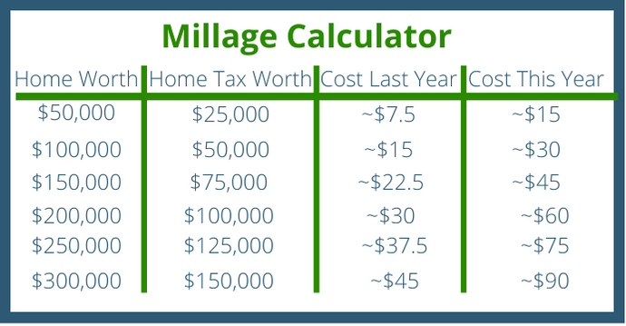

Want to know the taxable value of your home? It is stated on the top of your township tax bill.

